

2016

**Website Project**

**Tutor: Gill**

**Rose Le**

###### ConceptualiSation

**What opportunity or issue is the site addressing?**

This is a website about Travel information website of Vietnam tourism. People can research more information before they make a trip to Viet Nam. However , my site has not finished enough . In the future , i hope i can make the website like agency which tourists can book a tour from my web and include others services related.

**What is the motivation for the site?**

However , my site has not finished enough . In the future , i hope i can make the website like agency which tourists can book a tour from my web and include others services related.

###### Design

**Site map** (try [draw.io](http://draw.io))

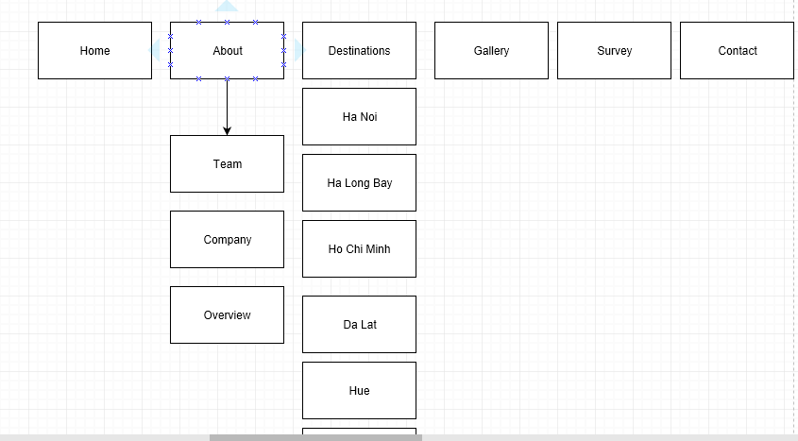

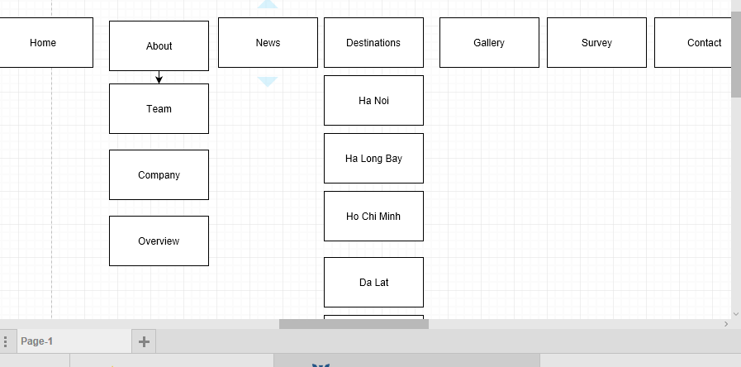

**Wireframe** (try[wireframe.cc](https://wireframe.cc/))

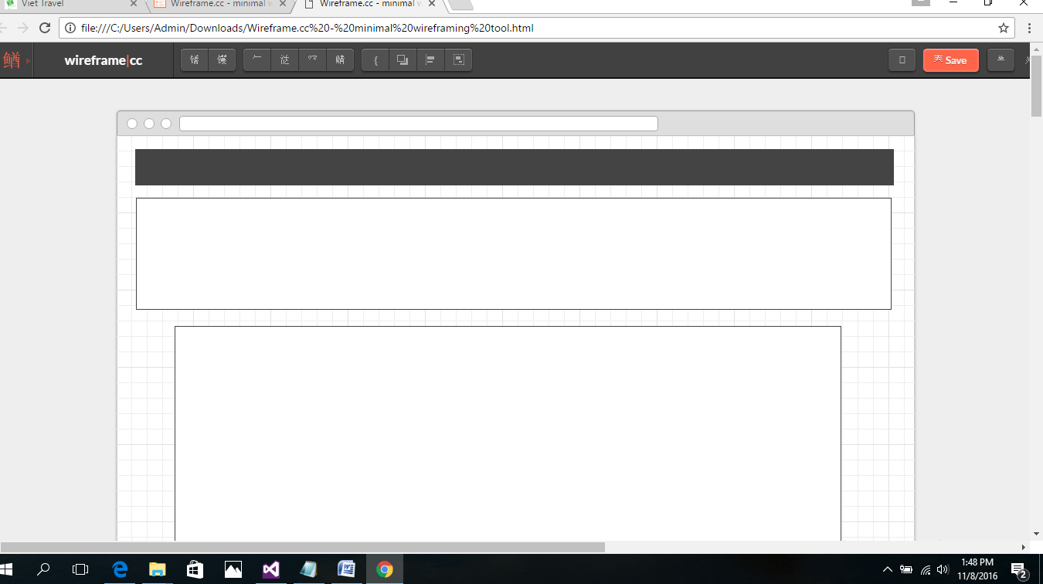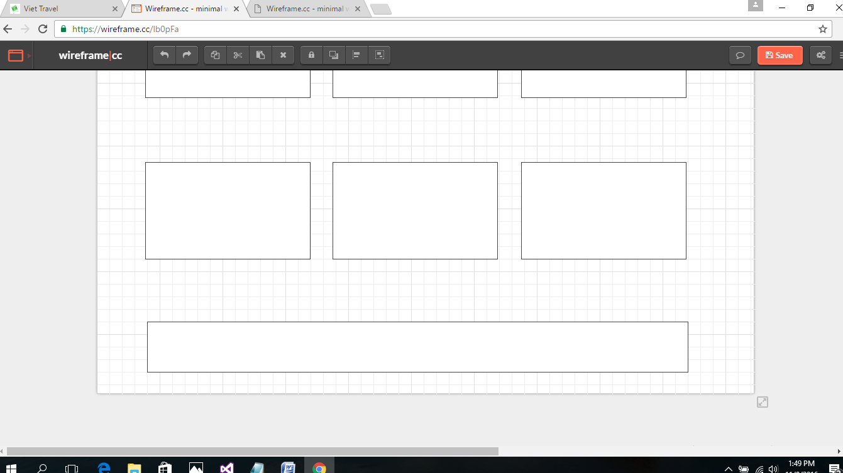

**Colour scheme**

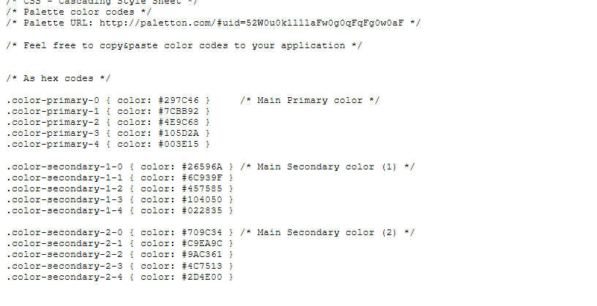

###### Content

* 1. Pages  
     The Website must consist of AT LEAST five pages (below are suggested pages)

**Homepage** *index.html*

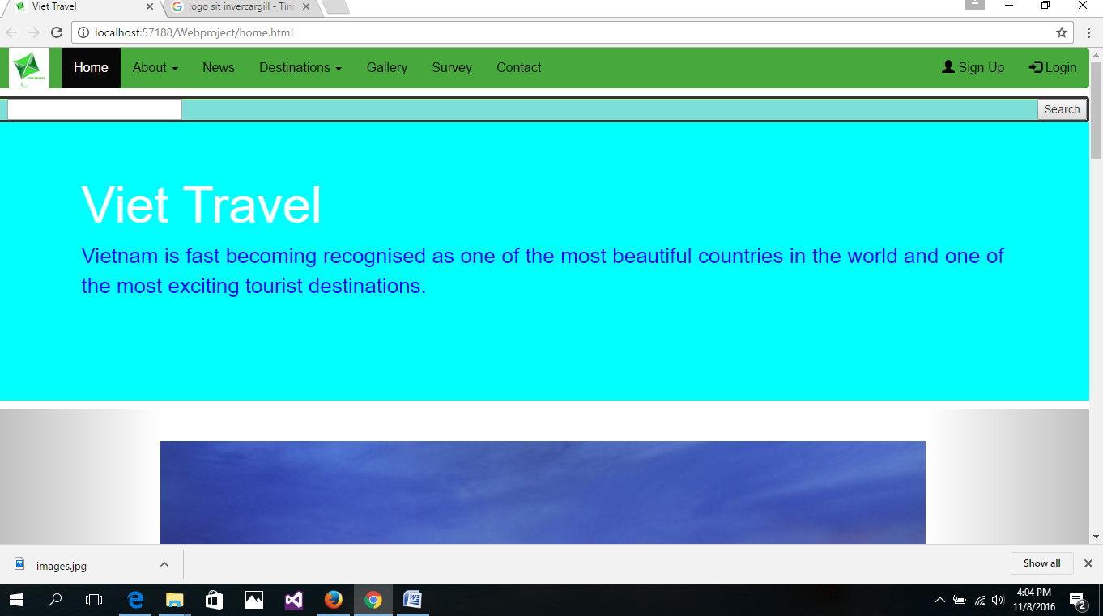

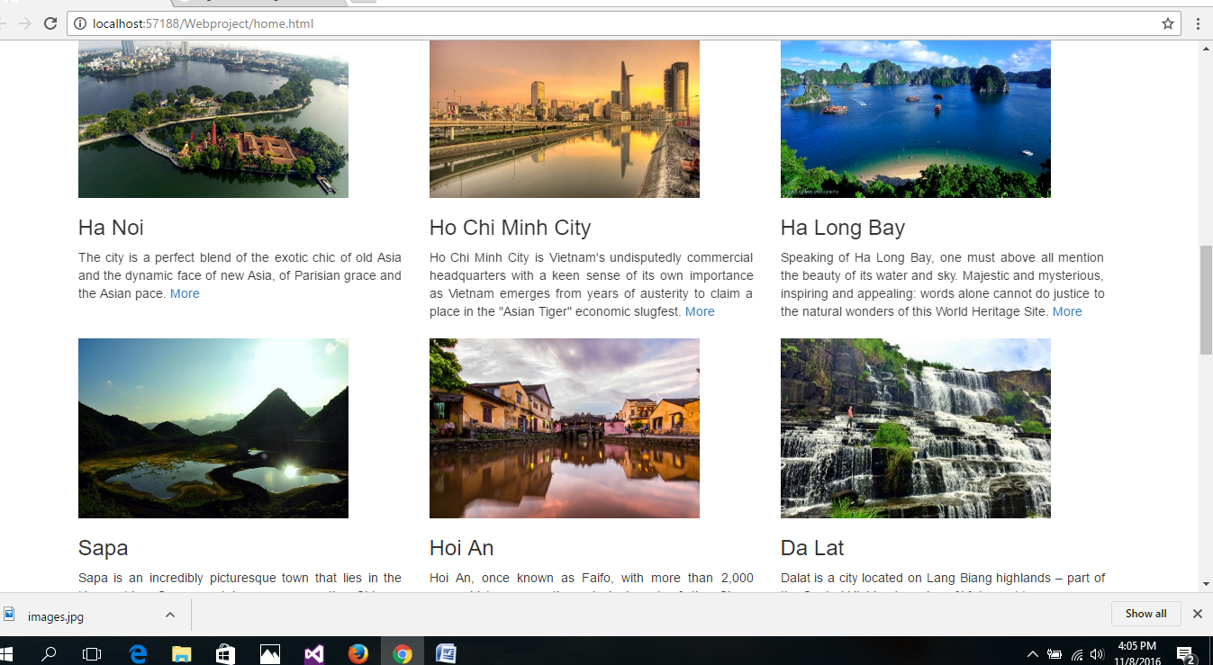

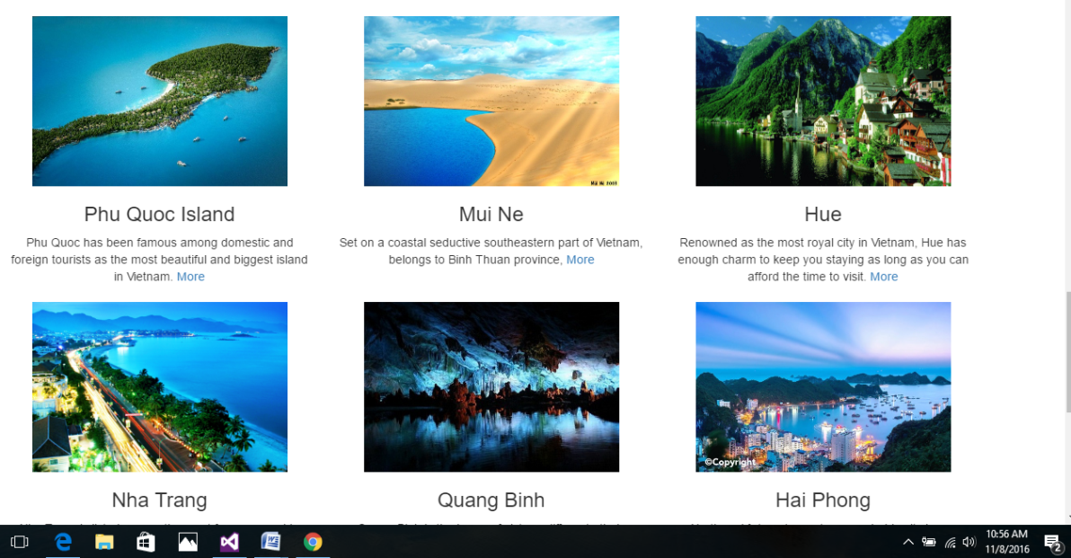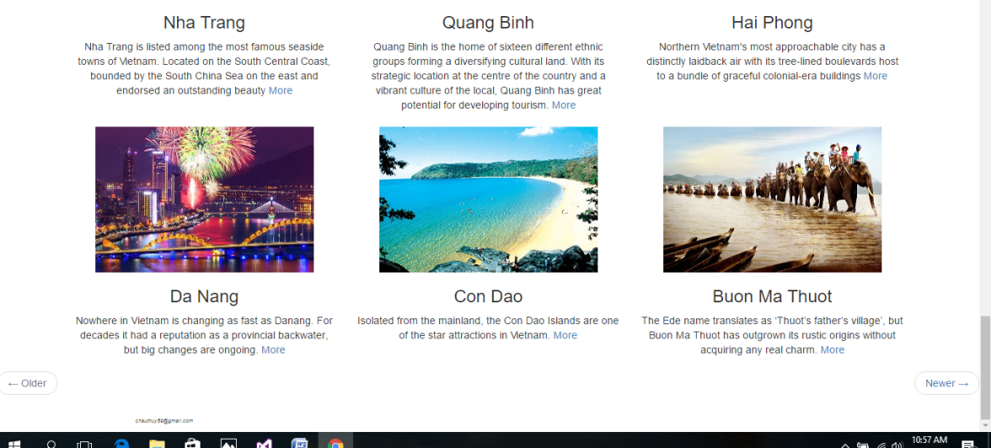

**About** *page about the website*

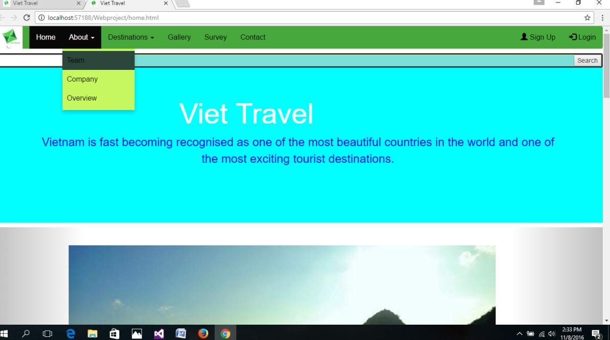

**News page**

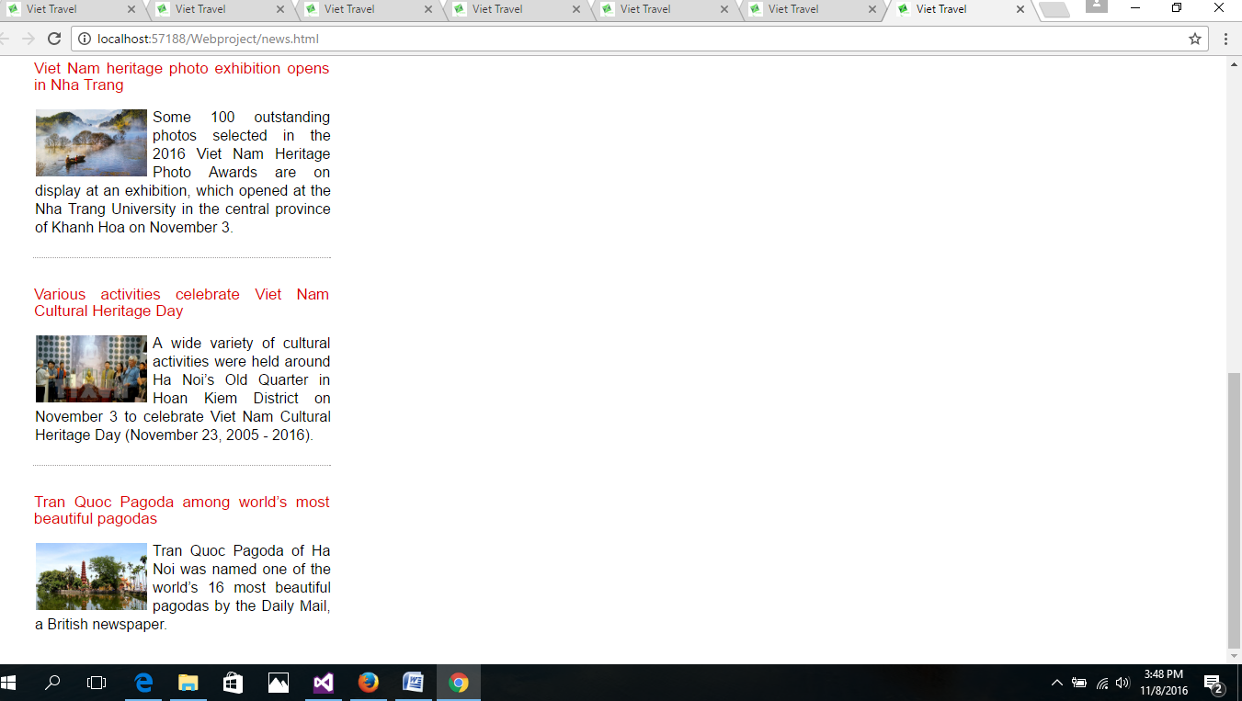

**Destinations**

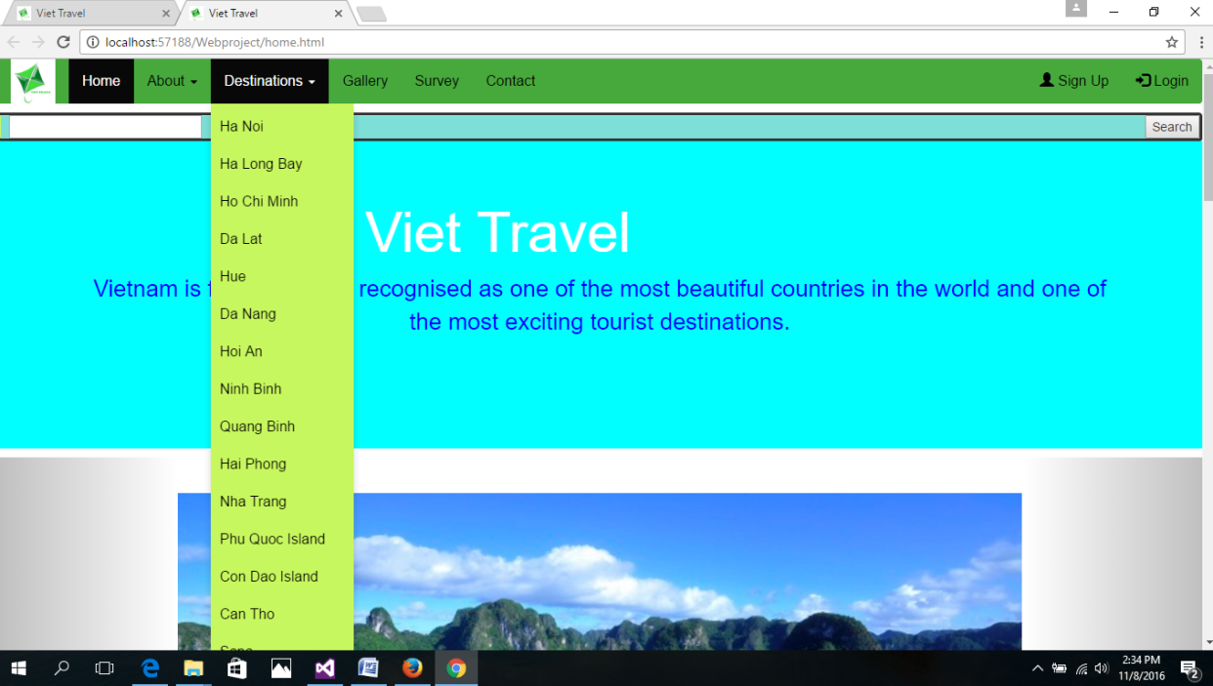

**Contact** *a contact page*

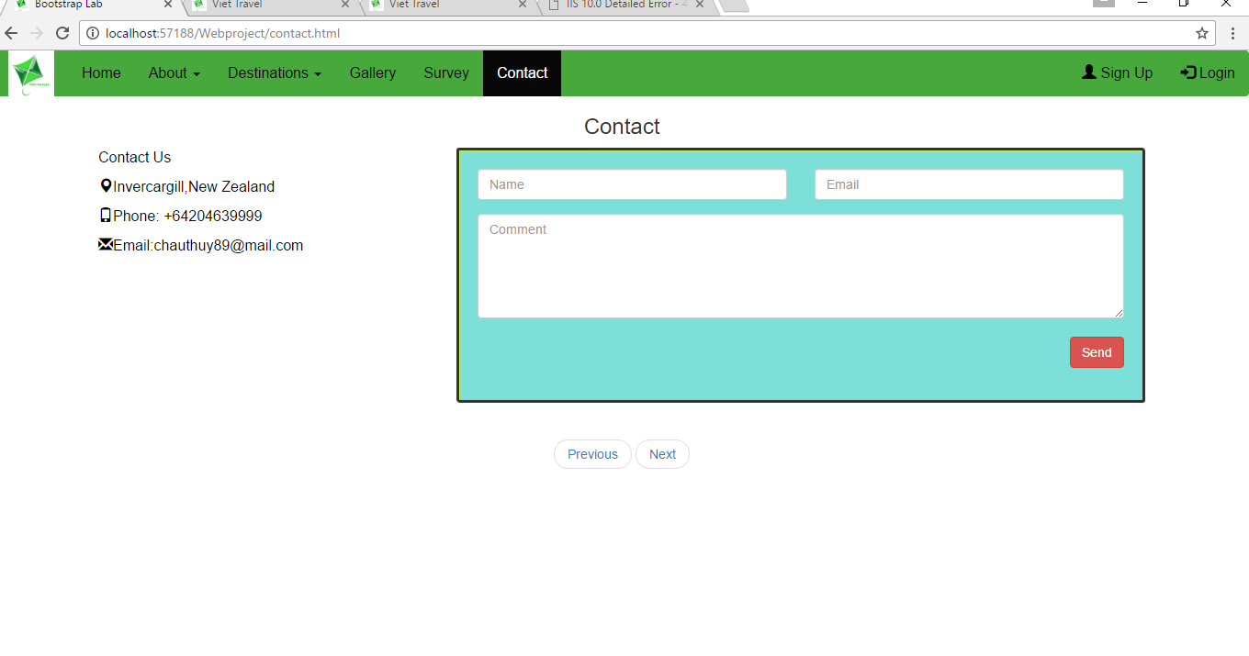

**Survey** *an evaluation survey*

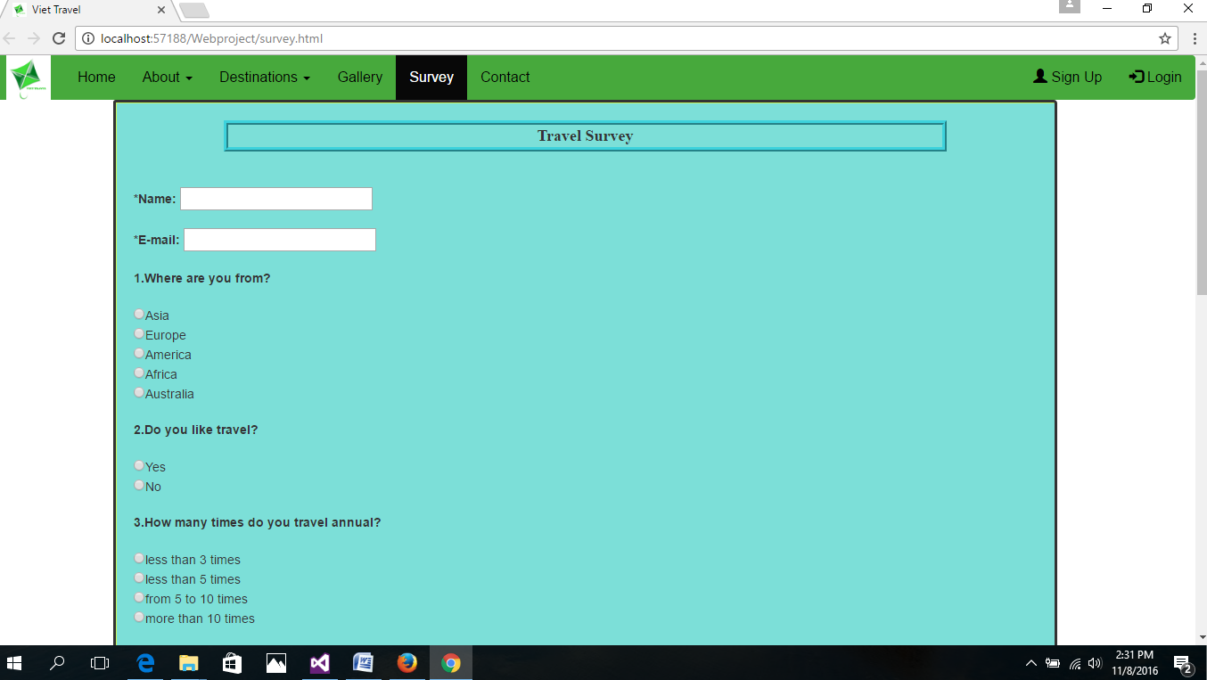

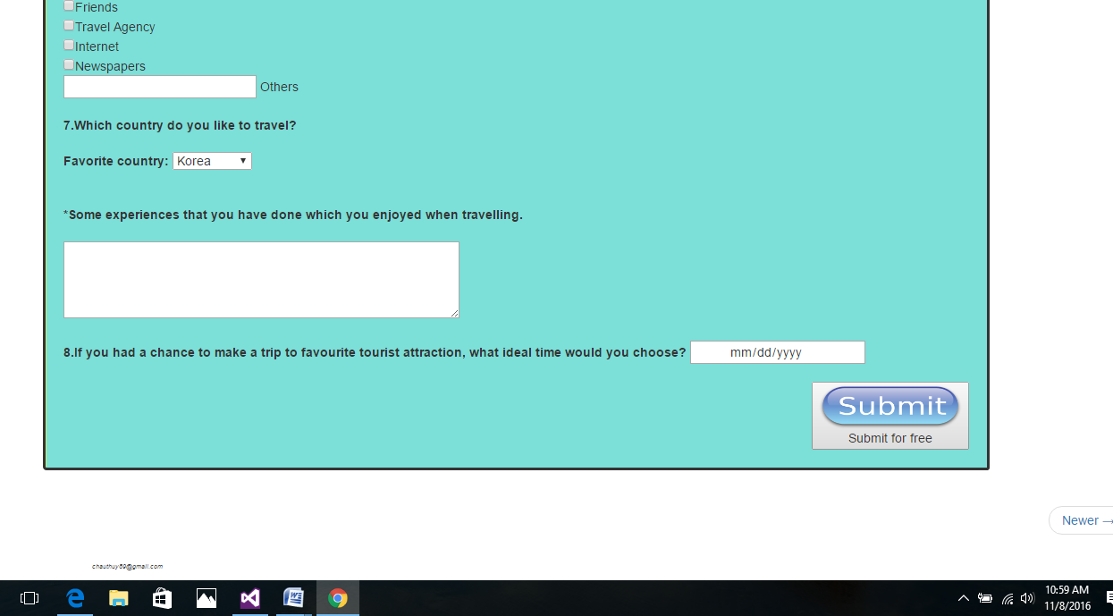

**Gallery** *an image gallery*

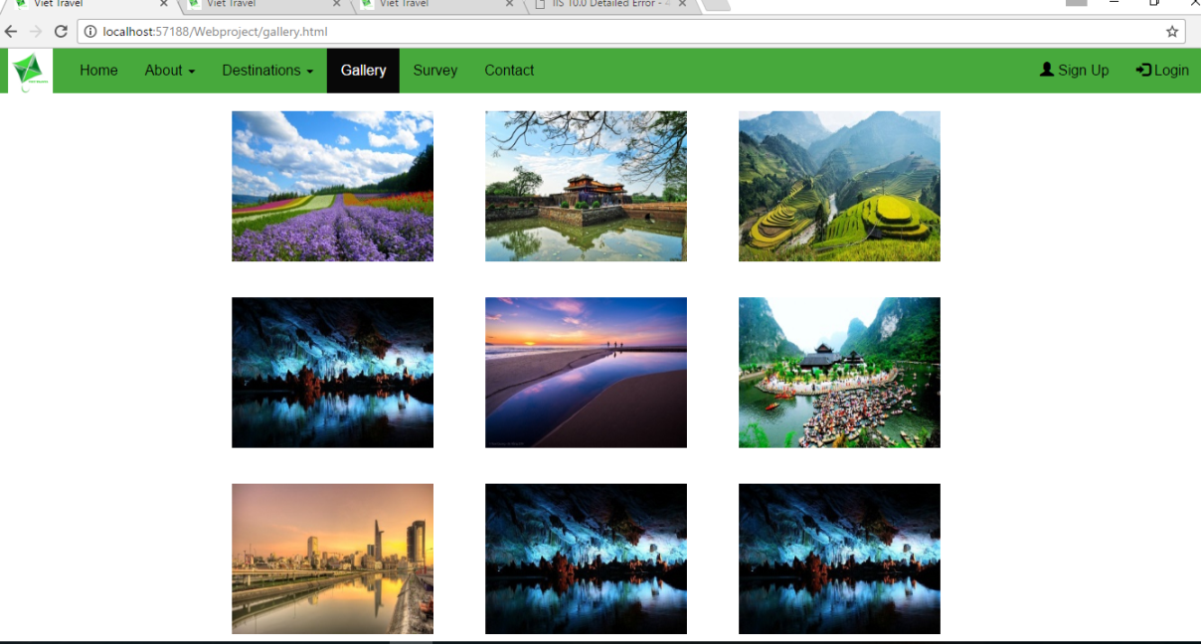

* 1. Features  
     Your web site must have at least the following features:

**Logo**

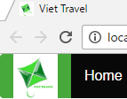

**Navigation menu**



**Images**

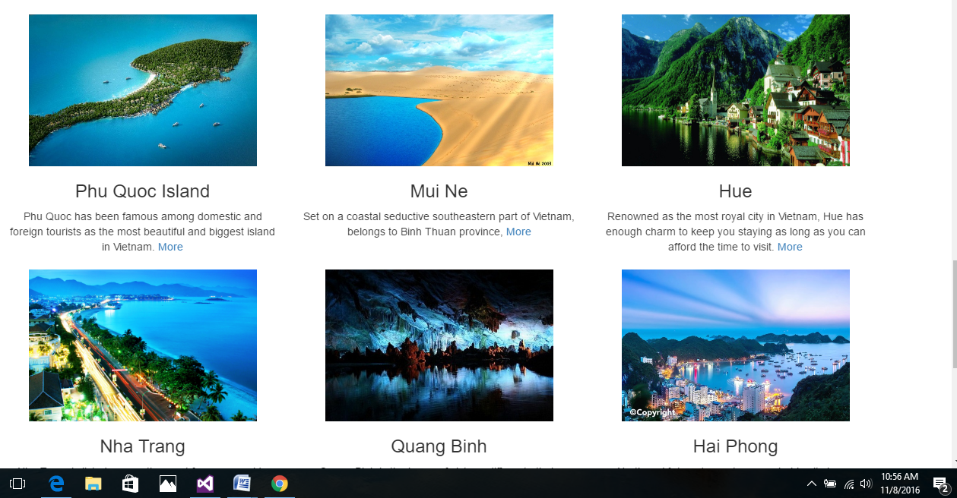

**Footer**

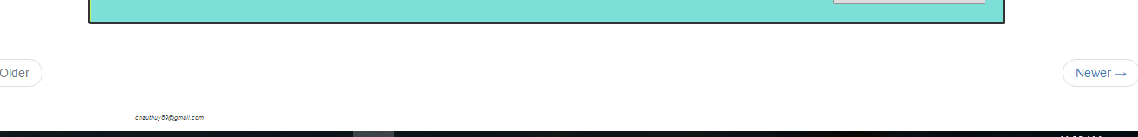

**Links** (that work)

* 1. Self-Researched Feature

1. <ul class="pager">
2. <li class="previous disabled"><a href="#">&larr; Older</a></li>
3. <li class="next"><a href="#">Newer &rarr;</a></li>
4. </ul>

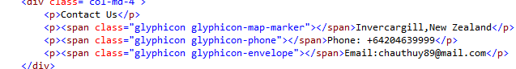

###### Web Design Best practices

1. **Page Layout**

**1.Appealing to Target Audience***My website is aimed at tourists and I have used images features to appeal to this audiences.*

**9.Good contrast between text and background***I used* [*http://paletton.com/#uid=52W0u0kllllaFw0g0qFqFg0w0aF*](http://paletton.com/#uid=52W0u0kllllaFw0g0qFqFg0w0aF) *o audit the contrast between the font colour and the background and this is my positive result test.* 

**13.Viewport metatagto display smartphone**

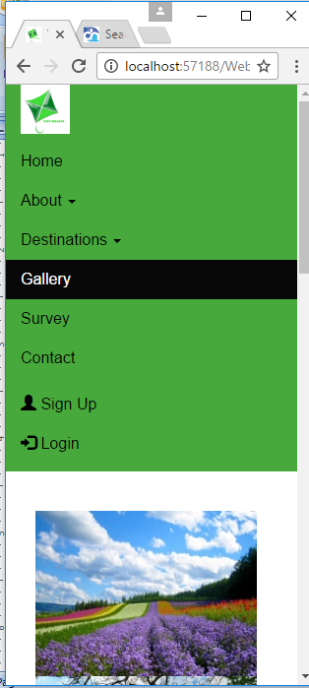

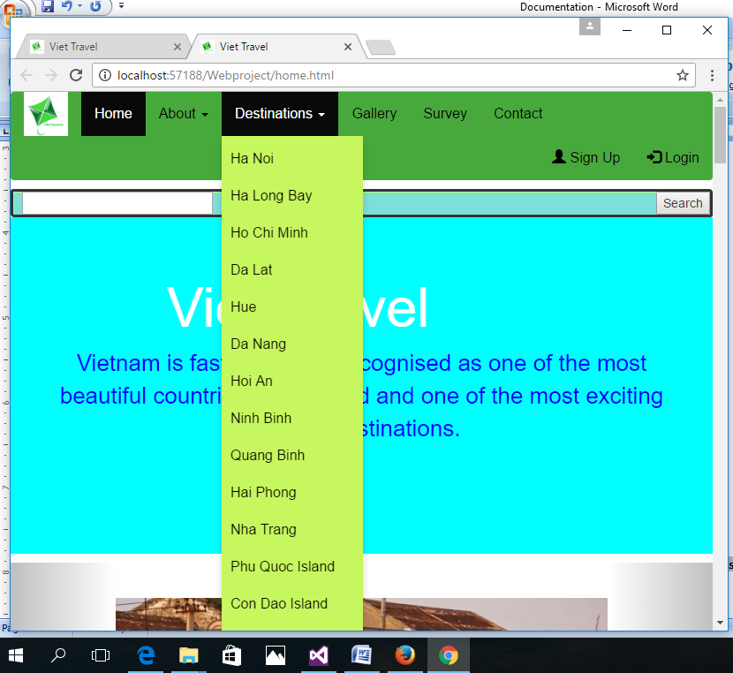

**14. Madia querris configure response page layout for smartphone and tablet display**

**8. Balance of text/grapics/whitespace**

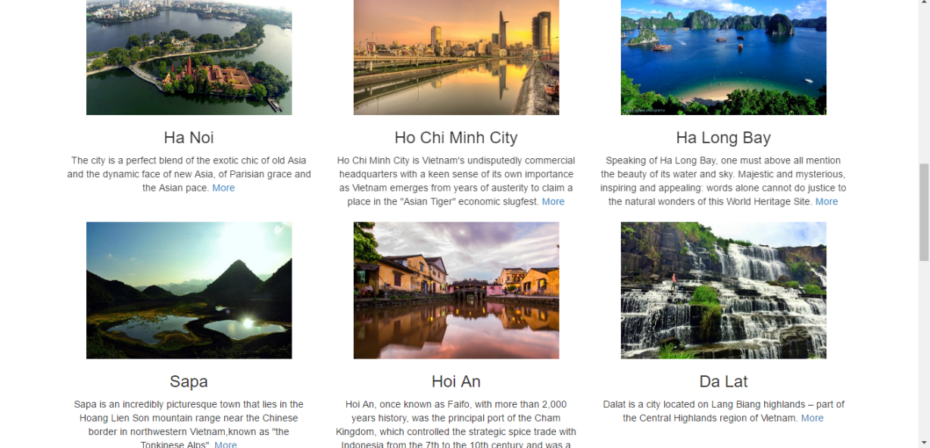

b.Navigation – up to 5 items

1.Main navigation links are clearly

2.Navigation is easy for target audience

5.Navigation is structured in an unordered list

7.Navigation hyperlinks work

c.Colour and Graphics– up to 5 items

1.colour scheme is limited to a maximum of three or four colors plus neutrals

2.Color is used consistently

3. Background and text colors have sufficient constrast

8. Image tags use the alt attribute to configure altenate text replacement

d.Content Presentation­– up to 8 items

1.Common fonts : Arial is used

3. Fonts, fonts size are consistently

7. Information is easy to find

e.Accessibility– up to 4 items

###### Testing

Firefox, Chrome,Explore

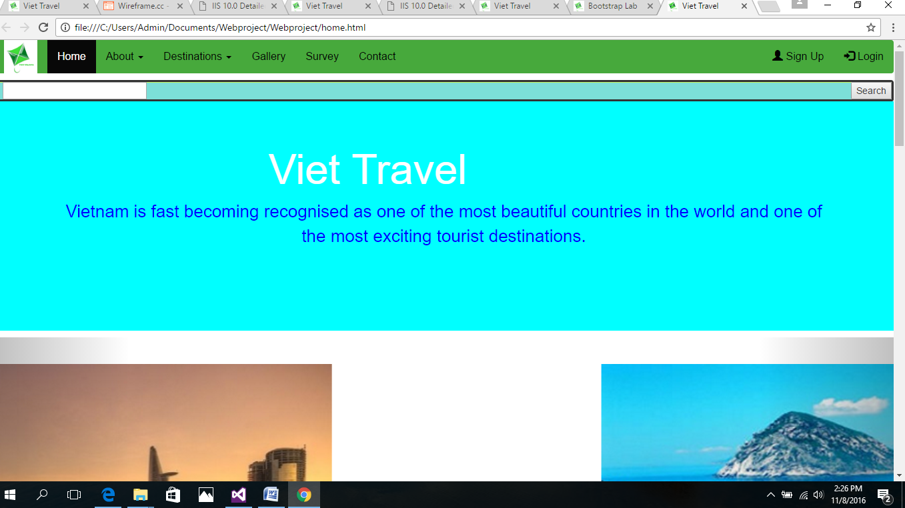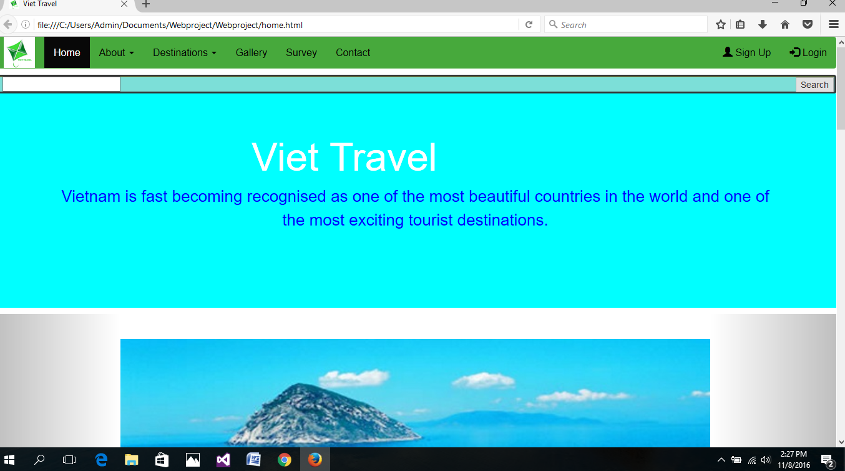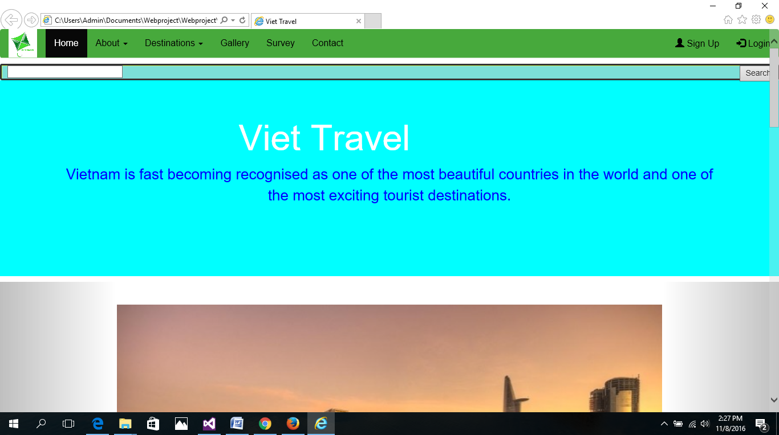

**Validate HTML and CSS document** (use[w3c.org validators](http://www.w3.org/developers/tools))

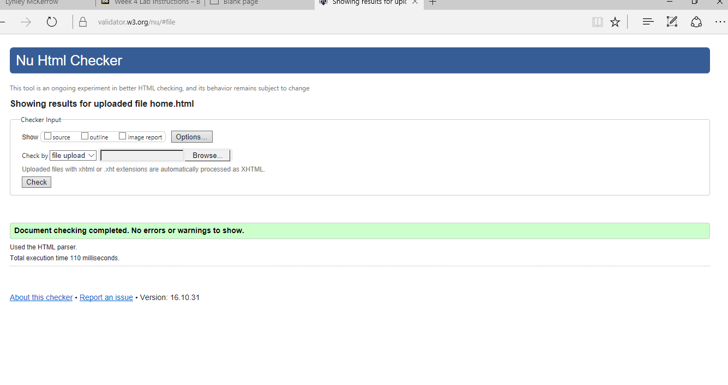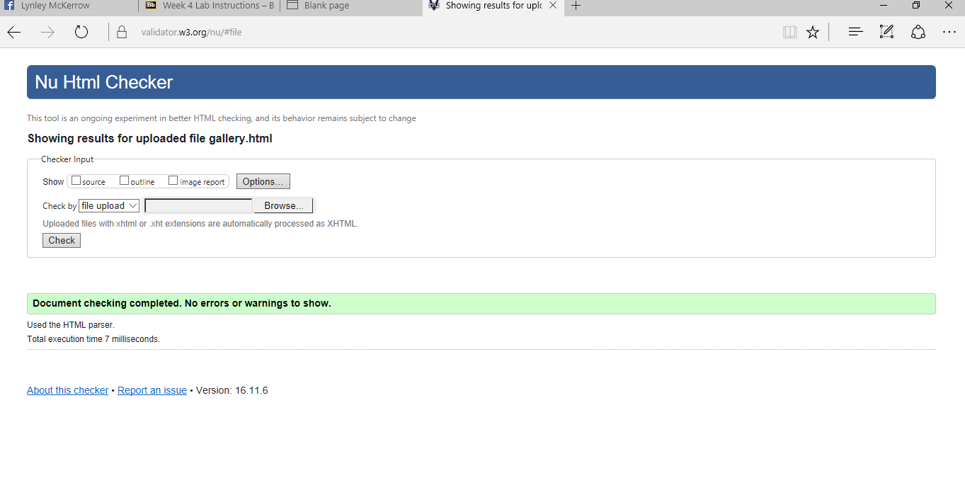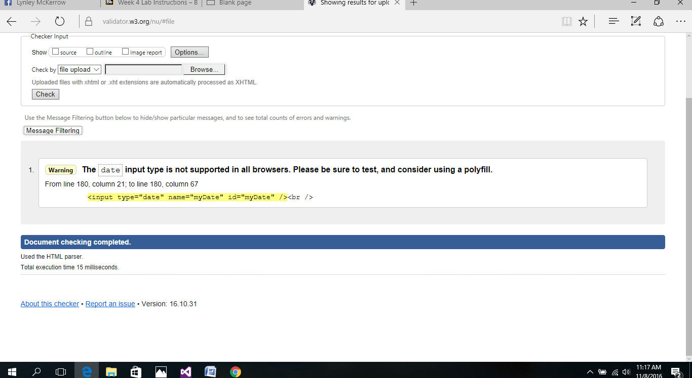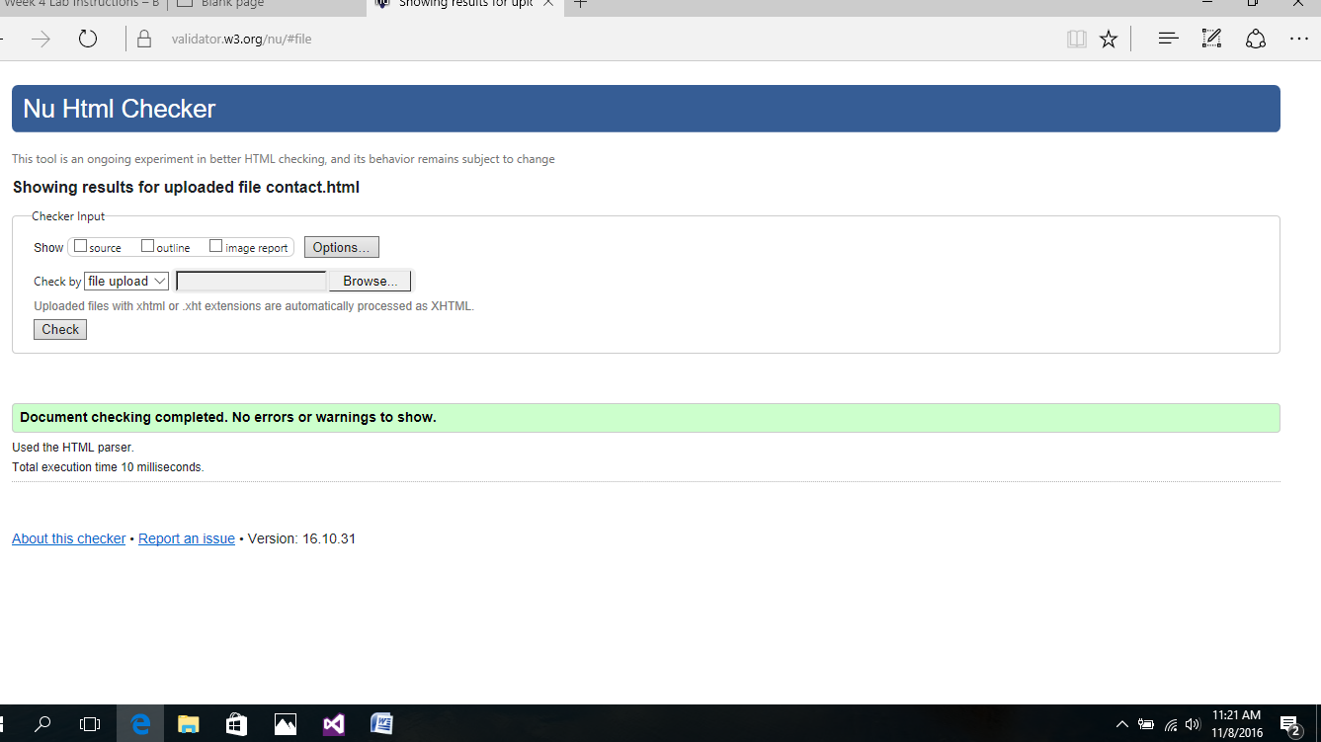

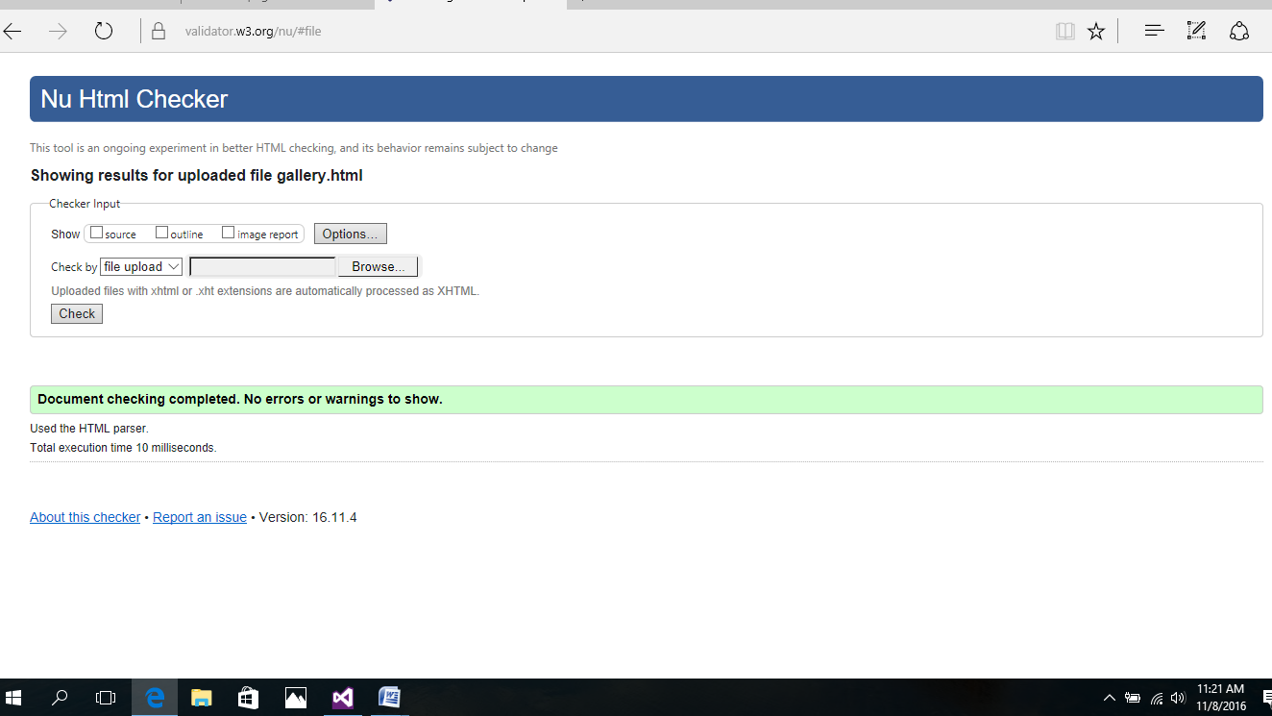

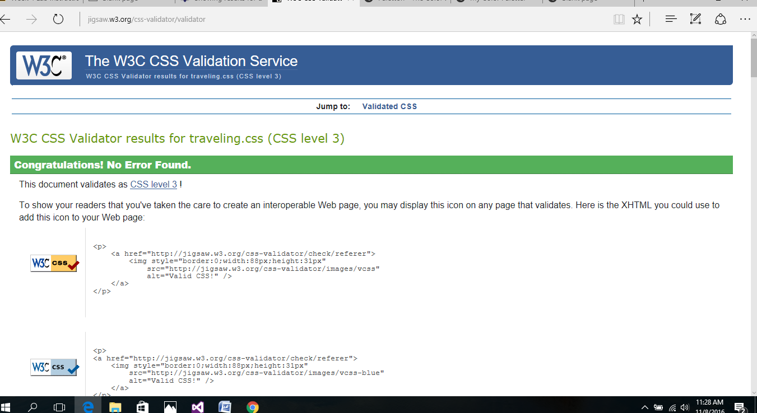

###### launch

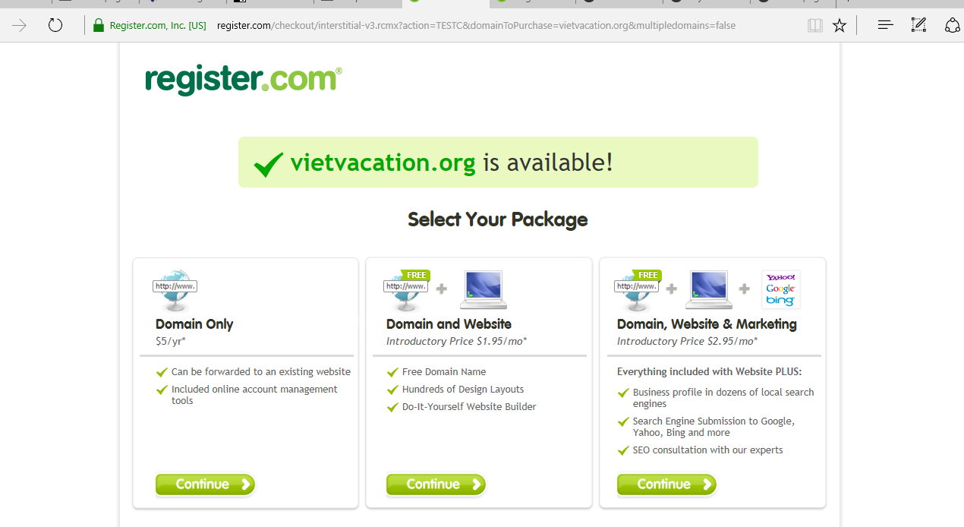

###### Maintenance

Tools for customer to book a tour, the background of page,

More information of destinations and about, news pages

###### SOURCE CODE

<!DOCTYPE html>

<html lang="en">

<head>

<meta charset="utf-8">

<meta http-equiv="X-UA-Compatible" content="IE=edge">

<meta name="viewport" content="width=device-width, initial-scale=1">

<!--The above 3 meta tags *must* come first in the head; any other head content must come *after* these tags -->

<title>Viet Travel</title>

<link href="logo.png" rel="shortcut icon" type="image/x-icon" />

<!--[if lt IE 9]><script src="http://html5shim.googlecode.com/svn/trunk/html5.js"></script><![endif]-->

<link href="css/bootstrap.min.css" rel="stylesheet">

<link href="css/traveling.css" rel="stylesheet">

<link href='https://fonts.googleapis.com/css?family=Montserrat:400,700' rel='stylesheet' type='text/css'>

<!--[if lt IE 9]>

<script src="https://oss.maxcdn.com/html5shiv/3.7.2/html5shiv.min.js"></script>

<script src="https://oss.maxcdn.com/respond/1.4.2/respond.min.js"></script>

<![endif]-->

<script src="https://ajax.googleapis.com/ajax/libs/jquery/1.11.3/jquery.min.js"></script>

<script>

$(document).ready(function() {

$('#more').click(function(){

$('#details').toggle();

});

$('#more1').click(function () {

$('#details1').toggle('false');

});

$('#more2').click(function () {

$('#details2').toggle('false');

});

$('#more3').click(function () {

$('#details3').toggle('false');

});

$('#more4').click(function () {

$('#details4').toggle('false');

});

$('#more5').click(function () {

$('#details5').toggle('false');

});

$('#more6').click(function () {

$('#details6').toggle('false');

});

$('#more7').click(function () {

$('#details7').toggle('false');

});

$('#more8').click(function () {

$('#details8').toggle('false');

});

$('#more9').click(function () {

$('#details9').toggle('false');

});

$('#more10').click(function () {

$('#details10').toggle('false');

});

$('#more11').click(function () {

$('#details11').toggle('false');

});

$('#more12').click(function () {

$('#details12').toggle('false');

});

$('#more13').click(function () {

$('#details13').toggle('false');

});

$('#more14').click(function () {

$('#details14').toggle('false');

});

});

</script>

</head>

<body>

<nav class="navbar navbar-inverse" data-spy="affix " data-offset-top="197">

<div class="container-fluid">

<div class="navbar-header">

<a class="navbar-brand" href="home.html"> <img id="mylogo" src="logo.png" alt="logo" height="50" width="50" /></a>

</div>

<ul class="nav navbar-nav">

<li class="active"><a href="home.html">Home</a></li>

<li class="dropdown">

<a class="dropdown-toggle" data-toggle="dropdown" href="about.html">

About

<span class="caret"></span>

</a>

<ul class="dropdown-menu">

<li><a href="team.html">Team</a></li>

<li><a href="company.html">Company</a></li>

<li><a href="overview.html">Overview</a></li>

</ul>

</li>

<li class="dropdown">

<a class="dropdown-toggle" data-toggle="dropdown" href="destinations.html">

Destinations

<span class="caret"></span>

</a>

<ul class="dropdown-menu">

<li><a href="hanoi.html">Ha Noi</a></li>

<li><a href="halongbay.html">Ha Long Bay</a></li>

<li><a href="hochiminh.html">Ho Chi Minh</a></li>

<li><a href="dalat.html">Da Lat</a></li>

<li><a href="hue.html">Hue</a></li>

<li><a href="danang.html">Da Nang</a></li>

<li><a href="hoian.html">Hoi An</a></li>

<li><a href="ninhbinh.html">Ninh Binh</a></li>

<li><a href="quangbinh.html">Quang Binh</a></li>

<li><a href="haiphong.html">Hai Phong</a></li>

<li><a href="nhatrang.html">Nha Trang</a></li>

<li><a href="phuquoc.html">Phu Quoc Island</a></li>

<li><a href="condao.html">Con Dao Island</a></li>

<li><a href="cantho.html">Can Tho</a></li>

<li><a href="sapa.html">Sapa</a></li>

<li>

<a href="muine.html">Mui Ne</a>

</li>

</ul>

</li>

<li><a href="gallery.html">Gallery</a></li>

<li><a href="survey.html">Survey</a></li>

<li><a href="contact.html">Contact</a></li>

</ul>

<ul class="nav navbar-nav navbar-right">

<li><a href="#"><span class="glyphicon glyphicon-user"></span> Sign Up</a></li>

<li><a href="#"><span class="glyphicon glyphicon-log-in"></span> Login</a></li>

</ul>

</div>

</nav>

<form id="searchform" action="http://www.google.com/search" method="get">

<input type="text" name="q">

<button type="Submit">Search</button>

</form>

<div class="jumbotron">

<div class="container">

<h1>Viet Travel</h1>

<p>

Vietnam is fast becoming recognised as one of the most beautiful countries in the world and one of the most exciting tourist destinations.<br />

</p>

<br>

</div>

<br /><br />

</div>

<div id="myCarousel" class="carousel slide" data-ride="carousel">

<!-- Indicators -->

<ol class="carousel-indicators">

<li data-target="#myCarousel" data-slide-to="0" class="active"></li>

<li data-target="#myCarousel" data-slide-to="1"></li>

<li data-target="#myCarousel" data-slide-to="2"></li>

<li data-target="#myCarousel" data-slide-to="3"></li>

<li data-target="#myCarousel" data-slide-to="4"></li>

<li data-target="#myCarousel" data-slide-to="5"></li>

<li data-target="#myCarousel" data-slide-to="6"></li>

<li data-target="#myCarousel" data-slide-to="7"></li>

</ol>

<br /><br />

<!-- Wrapper for slides -->

<div class="carousel-inner" role="listbox">

<div class="item active">

<img src="images/hochiminh.jpg" alt="vietnam" width="400" height="200">

</div>

<div class="item">

<img src="images/nhatrang2.jpg" alt="nhatrang" width="400" height="200">

</div>

<div class="item">

<img src="images/halongbay.jpg" alt="halong" width="400" height="200">

</div>

<div class="item">

<img src="images/sapa5.jpg" alt="sapa" width="400" height="200">

</div>

<div class="item">

<img src="images/hue4.jpg" alt="sapa" width="400" height="200">

</div>

<div class="item">

<img src="images/hoian.jpg" alt="sapa" width="400" height="200">

</div>

<div class="item">

<img src="images/dalat.jpg" alt="sapa" width="400" height="200">

</div>

<div class="item">

<img src="images/muine1.jpg" alt="muine" width="400" height="200">

</div>

</div>

<br />

<br />

<!-- Left and right controls -->

<a class="left carousel-control" href="#myCarousel" role="button" data-slide="prev">

<span class="glyphicon glyphicon-chevron-left" aria-hidden="true"></span>

<span class="sr-only">Previous</span>

</a>

<a class="right carousel-control" href="#myCarousel" role="button" data-slide="next">

<span class="glyphicon glyphicon-chevron-right" aria-hidden="true"></span>

<span class="sr-only">Next</span>

</a>

</div>

<div class="container">

<section class="messages">

<!-- .rows and .columns -->

<div class="row">

<div class="col-md-4">

<img src="images/hanoi2.jpg" alt="ha noi" width="300" height="200" />

<h3>Ha Noi</h3>

<div>

The city is a perfect blend of the exotic chic of old Asia and the dynamic face of new Asia, of Parisian grace and the Asian pace.

<a id="more"> More </a>

<div id="details" style="display:none;">

Hanoi is where imagination becomes reality.

One of many reasons why tourists love coming to Hanoi is because almost the entire city is covered with green trees. And, it has such diversity- from the old quarter to the urban areas.

Also, Hanoi is regarded as melting pot of Vietnam gastronomy. You can find all sorts of delicacies in this city which come in from other provinces.

</div>

</div>

</div>

<div class="col-md-4">

<img src="images/hochiminh.jpg" alt="ben thanh market" width="300" height="200" />

<h3>Ho Chi Minh City</h3>

<div>

Ho Chi Minh City is Vietnam's undisputedly commercial headquarters with a keen sense of its own importance as Vietnam emerges from years of austerity to claim a place in the "Asian Tiger" economic slugfest.

<a id="more1"> More </a>

<div id="details1" style="display:none;">

Located on the Saigon River, Ho Chi Minh City or Saigon as it is still called by all, is Vietnam's major port and largest city, and still survives in wide downtown avenues flanked by pristine colonials. Thousands of expatriates and Vietnamese immigrants couldn’t imagine living anywhere else. They’ve long since fallen for the hidden charms of one of Southeast Asia’s most hectic, and eclectic, cities.

</div>

</div>

</div>

<div class="col-md-4">

<img src="images/halongbay.jpg" alt="ha long bay" width="300" height="200">

<h3>Ha Long Bay</h3>

<div>

Speaking of Ha Long Bay, one must above all mention the beauty of its water and sky. Majestic and mysterious, inspiring and appealing: words alone cannot do justice to the natural wonders of this World Heritage Site.

<a id="more2"> More </a>

<div id="details2" style="display:none;">

With over 3 thousand incredible islands jutting out from the emerald waters of the Gulf of Tonkin that make up a vision of breathtaking beauty, Halong Bay is pure art and a priceless collection of unfinished sculptures hewn by the hand of nature.

Looking from above, Halong in our eyes appears to be an enormous and expressive picture of Mother Earth. By moving around, you feel as if you are walking in a fairyland with many petrified creatures surrounding you. There are rocks and even islets which form various extraordinary shapes—a Dragon, an Old Fisherman, and much more.

</div>

</div>

</div>

</div>

</section>

</div>

<br />

<div class="container">

<section class="messages">

<!-- .rows and .columns -->

<div class="row">

<div class="col-md-4">

<img src="images/sapa5.jpg" alt="sapa" width="300" height="200" />

<h3>Sapa</h3>

<div>

Sapa is an incredibly picturesque town that lies in the Hoang Lien Son mountain range near the Chinese border in northwestern Vietnam,known as "the Tonkinese Alps".

<a id="more3"> More </a>

<div id="details3" style="display:none;">

Sapa and its surrounding region is host to many hill tribes, as well as rice terraces, lush vegetation, and Fansipan, the highest peak in Vietnam.

Other great mountains like Aurora & J, where Sa Pa sees the first rays of sun, make up a very steep valley.

</div>

</div>

</div>

<div class="col-md-4">

<img src="images/hoian-bridge.jpg" alt="hoi an" width="300" height="200" />

<h3>Hoi An</h3>

<div>

Hoi An, once known as Faifo, with more than 2,000 years history, was the principal port of the Cham Kingdom, which controlled the strategic spice trade with Indonesia from the 7th to the 10th century and was a major international port in the 16th and 17th centuries

<a id="more4"> More </a>

<div id="details4" style="display:none;">

- and the foreign influences are discernible to this day.

The culture & heritage is mostly from the Cham people whose kingdom originally stretched from Hue South to Phan Thiet (South of Nha Trang) - the Champa's most likely originally from Java. The original Cham political capital was Tra Kieu, the commercial capital was Hoi An and the spiritual capital was My Son (Hindu).

The Cham people were Hindu, and by the 10th century the influence of Arab traders to Hoi An resulted in some converting to become Muslims.

The second major influence was from the Chinese, firstly from traders but especially the escaping Ming Dynasty armies who after settling in Hoi An for some years moved further south and created Saigon as a major trading port.

The third and last major influence of culture & heritage was from the Vietnamese and is fairly recent and only came after the Cham lost control of this area. For a tourist wanting Vietnamese culture & heritage, Hue is a much better destination than Hoi An (but the weather is much rougher too!).

</div>

</div>

</div>

<div class="col-md-4">

<img src="images/dalat2.jpg" alt="da lat" width="300" height="200">

<h3>Da Lat</h3>

<div>

Dalat is a city located on Lang Biang highlands – part of the Central Highlands region of Vietnam.

<a id="more5"> More </a>

<div id="details5" style="display:none;">

Dalat is a city located on Lang Biang highlands – part of the Central Highlands region of Vietnam.

Because of its history, special architecture, unique climate features and wide range of beautiful spots,

Dalat is known as one of the most popular tourist destinations of Vietnam.

</div>

</div>

</div>

</div>

</section>

</div>

<br />

<div class="container">

<section class="messages">

<!-- .rows and .columns -->

<div class="row">

<div class="col-md-4">

<img src="images/phuquoc1.jpg" alt="phu quoc" width="300" height="200" />

<h3>Phu Quoc Island</h3>

<div>

Phu Quoc has been famous among domestic and foreign tourists as the most beautiful and biggest island in Vietnam.

<a id="more6"> More </a>

<div id="details6" style="display:none;">

Phu Quoc has been famous among domestic and foreign tourists as the most beautiful and biggest island in Vietnam.

Despite being a long-time tourist attraction,

the island still possesses its extraordinary beauty with unspoiled white-sand beaches and quaint fishing villages.

</div>

</div>

</div>

<div class="col-md-4">

<img src="images/muine2.jpg" alt="mui ne" width="300" height="200"/>

<h3>Mui Ne</h3>

<div>

Set on a coastal seductive southeastern part of Vietnam, belongs to Binh Thuan province,

<a id="more7"> More </a>

<div id="details7" style="display:none;">

Set on a coastal seductive southeastern part of Vietnam, belongs to Binh Thuan province,

Mui Ne has been quickly transformed from a fishing village into a long stretch of beautiful resorts.

Tropical beach and strong sea breezes make it a capital for strenuous coast activities, especially kite-surfing and wind-surfing.

</div>

</div>

</div>

<div class="col-md-4">

<img src="images/hue3.jpg" alt="Hue" width="300" height="200">

<h3>Hue</h3>

<div>

Renowned as the most royal city in Vietnam, Hue has enough charm to keep you staying as long as you can afford the time to visit.

<a id="more8"> More </a>

<div id="details8" style="display:none;">

Located on the bank of Song Huong- Perfume River; Hue, the capital of Thua Thien Hue province in Central Vietnam, is 700 km southern Hanoi, 1100km northern Ho Chi Minh City, and only a few miles from the sea. Not until 1945 was Hue the national capital, the political, cultural and religious center of Vietnam under the control of Nguyen Dynasty.

Most well-known for its historic values; Hue had been recognized as one of the World Heritage Sites by UNESCO.

</div>

</div>

</div>

</div>

</section>

</div>

<br />

<div class="container">

<section class="messages">

<!-- .rows and .columns -->

<div class="row">

<div class="col-md-4">

<img src="images/nhatrang.jpg" alt="Nha Trang" width="300" height="200" />

<h3>Nha Trang</h3>

<div>

Nha Trang is listed among the most famous seaside towns of Vietnam.

Located on the South Central Coast, bounded by the South China Sea on the east and endorsed an outstanding beauty

<a id="more9"> More </a>

<div id="details9" style="display:none;">

with a favorable climate by nature,

Nha Trang is regarded as the Pearl of the Orient. Lovely white-sand beaches and interesting scuba diving activities are Nha Trang's main claim to fame.

Besides, being chosen place for several festivals as Miss Universe 2008, Miss World 2010,

and Annual Sea Festival has turned Nha Trang into an attractive destination drawing many tourists.

</div>

</div>

</div>

<div class="col-md-4">

<img src="images/quangbinh.jpg" alt="Quang Binh" width="300" height="200" />

<h3>Quang Binh</h3>

<div>

Quang Binh is the home of sixteen different ethnic groups forming a diversifying cultural land. With its strategic location at the centre of the country and a vibrant culture of the local, Quang Binh has great potential for developing tourism.

<a id="more10"> More </a>

<div id="details10" style="display:none;">

Quang Binh treasures a diverse collection of natural and human values made up from the geography, climate, historical background and social transformation process. Tourists are able to make a wide range of choice for their vacation there.

</div>

</div>

</div>

<div class="col-md-4">

<img src="images/haiphong.jpg" alt="con dao" width="300" height="200">

<h3>Hai Phong</h3>

<div>

Northern Vietnam's most approachable city has a distinctly laidback air with its tree-lined boulevards host to a bundle of graceful colonial-era buildings

<a id="more11"> More </a>

<div id="details11" style="display:none;">

. Caffeine-aficionado heaven, the central area buzzes with dinky cafes where tables spill out onto the pavements – perfect for people watching.

Apart from the cafe culture, there's not actually much to do and most travellers only use Haiphong as a transport hop between the bus from Hanoi and the ferry to Cat Ba Island.

If you do decide to linger, you'll find a friendly town with minimal hassles that makes a relaxing change from Vietnam's main tourism centres.

</div>

</div>

</div>

</div>

</section>

</div>

<br />

<div class="container">

<section class="messages">

<!-- .rows and .columns -->

<div class="row">

<div class="col-md-4">

<img src="images/danang.jpg" alt="Da Nang" width="300" height="200" />

<h3>Da Nang</h3>

<div>

Nowhere in Vietnam is changing as fast as Danang. For decades it had a reputation as a provincial backwater, but big changes are ongoing.

<a id="more12"> More </a>

<div id="details12" style="display:none;">

Stroll along the Han riverfront and you'll find gleaming new modernist hotels, and apartments and restaurants are emerging. Spectacular new bridges now span the Han river, and in the north of the city, the landmark new D-City is rising from the flatlands. Venture south and the entire China Beach strip is booming with hotel and resort developments.

That said, the city itself still has few conventional sightseeing spots, except for a very decent museum and a stunningly quirky bridge. So for most travellers, a few days enjoying the city’s beaches, restaurants and nightlife is probably enough. Book an after-dark tour to see Danang at its shimmering neon-lit best. The city's street food scene also deserves close investigation.

Danang also makes a great base for day trips. The city is part of a long thin peninsula, at the northern tip of which is Nui Son Tra (called Monkey Mountain by US soldiers). China Beach and the five Marble Mountains lie southwest of the city.

</div>

</div>

</div>

<div class="col-md-4">

<img src="images/condao.jpg" alt="Con Dao" width="300" height="200" />

<h3>Con Dao</h3>

<div>

Isolated from the mainland, the Con Dao Islands are one of the star attractions in Vietnam.

<a id="more13"> More </a>

<div id="details13" style="display:none;">

Long the Devil’s Island of Indochina, the preserve of political prisoners and undesirables, this place is now turning heads thanks to its striking natural beauty.

Con Son, the largest of this chain of 15 islands and islets, is ringed with lovely beaches, coral reefs and scenic bays, and remains partially covered in thick forests. In addition to hiking, diving and exploring empty coastal roads and deserted beaches, there are some excellent wildlife-watching opportunities such as the black giant squirrel and the endemic bow-fingered gecko.

</div>

</div>

</div>

<div class="col-md-4">

<img src="images/buonmathuot.jpg" alt="buon ma thuot" width="300" height="200">

<h3>Buon Ma Thuot</h3>

<div>

The Ede name translates as ‘Thuot’s father’s village’, but Buon Ma Thuot has outgrown its rustic origins without acquiring any real charm.

<a id="more14"> More </a>

<div id="details14" style="display:none;">

An affluent, modern, but rather characterless city (pronounced ‘boon me tote’), it is inundated by traffic from three highways.

Its two saving graces are its museum and its coffee: the region grows some of the best in Vietnam, plenty of which is sold and drunk in town.

Buon Ma Thuot plays host to an annual Coffee Festival in March that sees gallons of the black nectar drunk and elephant races held in nearby Don village.

Most travellers stop in Buon Ma Thuot en route to the attractions around it: Yok Don National Park, a couple of striking waterfalls and heaps of minority villages.

The province is home to 44 ethnic groups, the dominant groups being the Ede, Jarai, M’nong and Lao.

</div>

</div>

</div>

</div>

</section>

</div>

<ul class="pager">

<li class="previous disabled"><a href="#">&larr; Older</a></li>

<li class="next"><a href="#">Newer &rarr;</a></li>

</ul>

<!-- jQuery (necessary for Bootstrap's JavaScript plugins) -->

<script src="https://ajax.googleapis.com/ajax/libs/jquery/1.11.3/jquery.min.js"></script>

<script src="js/bootstrap.min.js"></script>

<footer>

<small>chauthuy89@gmail.com</small>

</footer>

</body>

</html>

Contact page

<!DOCTYPE html>

<html lang="en">

<head>

<meta charset="utf-8">

<meta http-equiv="X-UA-Compatible" content="IE=edge">

<meta name="viewport" content="width=device-width, initial-scale=1">

<!--The above 3 meta tags *must* come first in the head; any other head content must come *after* these tags -->

<title>Bootstrap Lab</title>

<link href="logo.png" rel="shortcut icon" type="image/x-icon" />

<!--[if lt IE 9]><script src="http://html5shim.googlecode.com/svn/trunk/html5.js"></script><![endif]-->

<link href="css/bootstrap.min.css" rel="stylesheet">

<link href="css/traveling.css" rel="stylesheet">

<link href='https://fonts.googleapis.com/css?family=Montserrat:400,700' rel='stylesheet' type='text/css'>

<!--[if lt IE 9]>

<script src="https://oss.maxcdn.com/html5shiv/3.7.2/html5shiv.min.js"></script>

<script src="https://oss.maxcdn.com/respond/1.4.2/respond.min.js"></script>

<![endif]-->

</head>

<body>

<div class="container-fluid" style="background-image:url(images/bannertravel.jpg)">

</div>

<nav class="navbar navbar-inverse" data-spy="affix " data-offset-top="197">

<div class="container-fluid">

<div class="navbar-header">

<a class="navbar-brand" href="home.html"> <img id="mylogo" src="logo.png" alt="logo" height="50" width="50" /></a>

</div>

<ul class="nav navbar-nav">

<li ><a href="home.html">Home</a></li>

<li class="dropdown">

<a class="dropdown-toggle" data-toggle="dropdown" href="about.html">

About

<span class="caret"></span>

</a>

<ul class="dropdown-menu">

<li><a href="team.html">Team</a></li>

<li><a href="company.html">Company</a></li>

<li><a href="overview.html">Overview</a></li>

</ul>

</li>

<li class="dropdown">

<a class="dropdown-toggle" data-toggle="dropdown" href="destinations.html">

Destinations

<span class="caret"></span>

</a>

<ul class="dropdown-menu">

<li><a href="hanoi.html">Ha Noi</a></li>

<li><a href="halongbay.html">Ha Long Bay</a></li>

<li><a href="hochiminh.html">Ho Chi Minh</a></li>

<li><a href="dalat.html">Da Lat</a></li>

<li><a href="hue.html">Hue</a></li>

<li><a href="danang.html">Da Nang</a></li>

<li><a href="hoian.html">Hoi An</a></li>

<li><a href="ninhbinh.html">Ninh Binh</a></li>

<li><a href="quangbinh.html">Quang Binh</a></li>

<li><a href="haiphong.html">Hai Phong</a></li>

<li><a href="nhatrang.html">Nha Trang</a></li>

<li><a href="phuquoc.html">Phu Quoc Island</a></li>

<li><a href="condao.html">Con Dao Island</a></li>

<li><a href="cantho.html">Can Tho</a></li>

<li><a href="sapa.html">Sapa</a></li>

<li>

<a href="muine.html">Mui Ne</a>

</li>

</ul>

<li><a href="gallery.html">Gallery</a></li>

<li><a href="survey.html">Survey</a></li>

<li class="active" ><a href="contact.html">Contact</a></li>

</ul>

<ul class="nav navbar-nav navbar-right">

<li><a href="#"><span class="glyphicon glyphicon-user"></span> Sign Up</a></li>

<li><a href="#"><span class="glyphicon glyphicon-log-in"></span> Login</a></li>

</ul>

</div>

</nav>

<!-- Container (Contact Section) -->

<div id="contact" class="container">

<h3 class="text-center">Contact</h3>

<p class="text-center"><em></em></p>

<div class="row">

<div class="col-md-4">

<p>Contact Us</p>

<p><span class="glyphicon glyphicon-map-marker"></span>Invercargill,New Zealand</p>

<p><span class="glyphicon glyphicon-phone"></span>Phone: +64204639999</p>

<p><span class="glyphicon glyphicon-envelope"></span>Email:chauthuy89@mail.com</p>

</div>

<div class="col-md-8">

<form id="myform" method="post" action="http://webdevbasics.net/scripts/demo.php">

<div class="row">

<div class="col-sm-6 form-group">

<input class="form-control" id="name" name="name" placeholder="Name" type="text" required>

</div>

<div class="col-sm-6 form-group">

<input class="form-control" id="email" name="email" placeholder="Email" type="email" required>

</div>

</div>

<textarea class="form-control" id="comments" name="comments" placeholder="Comment" rows="5"></textarea>

<br>

<div class="row">

<div class="col-md-12 form-group">

<button class="btn pull-right btn-danger" type="submit">Send</button>

</div>

</div>

</form>

</div>

</div>

</div>

<br>

<ul class="pager">

<li><a href="#">Previous</a></li>

<li><a href="#">Next</a></li>

</ul>

<!-- jQuery (necessary for Bootstrap's JavaScript plugins) -->

<script src="https://ajax.googleapis.com/ajax/libs/jquery/1.11.3/jquery.min.js"></script>

<script src="js/bootstrap.min.js"></script>

<footer>

</footer>

</body>

</html>

Gallery page

<!DOCTYPE html>

<html lang="en">

<head>

<meta charset="utf-8">

<meta http-equiv="X-UA-Compatible" content="IE=edge">

<meta name="viewport" content="width=device-width, initial-scale=1">

<!--The above 3 meta tags *must* come first in the head; any other head content must come *after* these tags -->

<title>Viet Travel</title>

<link href="logo.png" rel="shortcut icon" type="image/x-icon" />

<!--[if lt IE 9]><script src="http://html5shim.googlecode.com/svn/trunk/html5.js"></script><![endif]-->

<link href="css/bootstrap.min.css" rel="stylesheet">

<link href="css/traveling.css" rel="stylesheet">

<link href='https://fonts.googleapis.com/css?family=Montserrat:400,700' rel='stylesheet' type='text/css'>

<!--[if lt IE 9]>

<script src="https://oss.maxcdn.com/html5shiv/3.7.2/html5shiv.min.js"></script>

<script src="https://oss.maxcdn.com/respond/1.4.2/respond.min.js"></script>

<![endif]-->

<script>

$(document).ready(function(){

$('#gallery a').click(function(){

var galleryHref = $(this).attr('href');

var galleryAlt = $(this).attr('title');

$('figure').css('display','none');

$('figure img').attr({ src: galleryHref, alt: galleryAlt });

$('figcaption').html(galleryAlt);

$('figure').fadeToggle(1000);

return false;

});

});</script>

<!-- jQuery (necessary for Bootstrap's JavaScript plugins) -->

<script src="https://ajax.googleapis.com/ajax/libs/jquery/1.11.3/jquery.min.js"></script>

</head>

<body>

<div class="container-fluid" style="background-image:url(images/nhatrang2.jpg)">

</div>

<nav class="navbar navbar-inverse" data-spy="affix" data-offset-top="197">

<div class="container-fluid">

<div class="navbar-header">

<a class="navbar-brand" href="home.html"> <img id="mylogo" src="logo.png" alt="logo" height="50" width="50" /></a>

</div>

<ul class="nav navbar-nav">

<li><a href="home.html">Home</a></li>

<li class="dropdown">

<a class="dropdown-toggle" data-toggle="dropdown" href="#">

About

<span class="caret"></span>

</a>

<ul class="dropdown-menu">

<li><a href="team.html">Team</a></li>

<li><a href="company.html">Company</a></li>

<li><a href="overview.html">Overview</a></li>

</ul>

</li>

<li><a href=”news.html”>News</a><li>

<li class="dropdown">

<a class="dropdown-toggle" data-toggle="dropdown" href="destinations.html">

Destinations

<span class="caret"></span>

</a>

<ul class="dropdown-menu">

<li><a href="hanoi.html">Ha Noi</a></li>

<li><a href="halongbay.html">Ha Long Bay</a></li>

<li><a href="hochiminh.html">Ho Chi Minh</a></li>

<li><a href="dalat.html">Da Lat</a></li>

<li><a href="hue.html">Hue</a></li>

<li><a href="danang.html">Da Nang</a></li>

<li><a href="hoian.html">Hoi An</a></li>

<li><a href="ninhbinh.html">Ninh Binh</a></li>

<li><a href="quangbinh.html">Quang Binh</a></li>

<li><a href="haiphong.html">Hai Phong</a></li>

<li><a href="nhatrang.html">Nha Trang</a></li>

<li><a href="phuquoc.html">Phu Quoc Island</a></li>

<li><a href="condao.html">Con Dao Island</a></li>

<li><a href="cantho.html">Can Tho</a></li>

<li><a href="sapa.html">Sapa</a></li>

<li>

<a href="muine.html">Mui Ne</a>

</li>

</ul>

</li>

<li class="active"><a href="gallery.html">Gallery</a></li>

<li><a href="survey.html">Survey</a></li>

<li><a href="contact.html">Contact</a></li>

</ul>

<ul class="nav navbar-nav navbar-right">

<li><a href="#"><span class="glyphicon glyphicon-user"></span> Sign Up</a></li>

<li><a href="#"><span class="glyphicon glyphicon-log-in"></span> Login</a></li>

</ul>

</div>

</nav>

<div id="gallery" class="col-md-12">

<div class="row col-md-8 col-md-offset-2">

<div class="col-md-4">

<a href="images/dalat.jpg" title="Da Lat"><img src="images/dalatthumb.jpg" alt="Da Lat" width="225" height="168" /></a>

</div>

<div class="col-md-4">

<a href="images/hue.jpg" title="Hue"><img src="images/huethumb.jpg" alt="Hue" width="225" height="168" /></a>

</div>

<div class="col-md-4">

<a href="images/vietnam.jpg" title="Viet Nam"><img src="images/vietnamthumb.jpg" alt="Viet Nam" width="225" height="168" /></a>

</div>

</div>

<div class="row col-md-8 col-md-offset-2 ">

<div class="col-md-4">

<a href="images/quangbinh.jpg" title="Quang Binh"><img src="images/quangbinhthumb.jpg" alt="Da Lat" width="225" height="168" /></a>

</div>

<div class="col-md-4">

<a href="images/danangmykhe.jpg" title="Da Nang"><img src="images/danangmykhethumb.jpg" alt="Da Nang" width="225" height="168" /></a>

</div>

<div class="col-md-4">

<a href="images/ninhbinh1.jpg" title="Ninh Binh"><img src="images/ninhbinh1thumb.jpg" alt="Ninh Binh" width="225" height="168" /></a>

</div>

</div>

<div class="row col-md-8 col-md-offset-2 ">

<div class="col-md-4">

<a href="images/hochiminh.jpg" title="Ho Chi Minh"><img src="images/hochiminhthumb.jpg" alt="Ho Chi Minh" width="225" height="168" /></a>

</div>

<div class="col-md-4">

<a href="images/quangbinh.jpg" title="Quang Binh"><img src="images/quangbinhthumb.jpg" alt="Da Lat" width="225" height="168" /></a>

</div>

<div class="col-md-4">

<a href="images/quangbinh.jpg" title="Quang Binh"><img src="images/quangbinhthumb.jpg" alt="Da Lat" width="225" height="168" /></a>

</div>

</div>

</div>

</body>

</html>

Survey page

<!DOCTYPE html>

<html lang="en">

<head>

<meta charset="utf-8">

<meta http-equiv="X-UA-Compatible" content="IE=edge">

<meta name="viewport" content="width=device-width, initial-scale=1">

<!--The above 3 meta tags *must* come first in the head; any other head content must come *after* these tags -->

<title>Viet Travel</title>

<link href="logo.png" rel="shortcut icon" type="image/x-icon" />

<!--[if lt IE 9]><script src="http://html5shim.googlecode.com/svn/trunk/html5.js"></script><![endif]-->

<link href="css/bootstrap.min.css" rel="stylesheet">

<link href="css/traveling.css" rel="stylesheet">

<link href='https://fonts.googleapis.com/css?family=Montserrat:400,700' rel='stylesheet' type='text/css'>

<!--[if lt IE 9]>

<script src="https://oss.maxcdn.com/html5shiv/3.7.2/html5shiv.min.js"></script>

<script src="https://oss.maxcdn.com/respond/1.4.2/respond.min.js"></script>

<![endif]-->

<script src="https://ajax.googleapis.com/ajax/libs/jquery/1.11.3/jquery.min.js"></script>

</head>

<body>

<nav class="navbar navbar-inverse" data-spy="affix " data-offset-top="197">

<div class="container-fluid">

<div class="navbar-header">

<a class="navbar-brand" href="home.html"> <img id="mylogo" src="logo.png" alt="logo" height="50" width="50" /></a>

</div>

<ul class="nav navbar-nav">

<li><a href="home.html">Home</a></li>

<li class="dropdown">

<a class="dropdown-toggle" data-toggle="dropdown" href="about.html">

About

<span class="caret"></span>

</a>

<ul class="dropdown-menu">

<li><a href="team.html">Team</a></li>

<li><a href="company.html">Company</a></li>

<li><a href="overview.html">Overview</a></li>

</ul>

</li>

<li class="dropdown">

<a class="dropdown-toggle" data-toggle="dropdown" href="destinations.html">

Destinations

<span class="caret"></span>

</a>

<ul class="dropdown-menu">

<li><a href="hanoi.html">Ha Noi</a></li>

<li><a href="halongbay.html">Ha Long Bay</a></li>

<li><a href="hochiminh.html">Ho Chi Minh</a></li>

<li><a href="dalat.html">Da Lat</a></li>

<li><a href="hue.html">Hue</a></li>

<li><a href="danang.html">Da Nang</a></li>

<li><a href="hoian.html">Hoi An</a></li>

<li><a href="ninhbinh.html">Ninh Binh</a></li>

<li><a href="quangbinh.html">Quang Binh</a></li>

<li><a href="haiphong.html">Hai Phong</a></li>

<li><a href="nhatrang.html">Nha Trang</a></li>

<li><a href="phuquoc.html">Phu Quoc Island</a></li>

<li><a href="condao.html">Con Dao Island</a></li>

<li><a href="cantho.html">Can Tho</a></li>

<li><a href="sapa.html">Sapa</a></li>

<li>

<a href="muine.html">Mui Ne</a>

</li>

</ul>

</li>

<li><a href="gallery.html">Gallery</a></li>

<li class="active"><a href="survey.html">Survey</a></li>

<li><a href="contact.html">Contact</a></li>

</ul>

<ul class="nav navbar-nav navbar-right">

<li><a href="#"><span class="glyphicon glyphicon-user"></span> Sign Up</a></li>

<li><a href="#"><span class="glyphicon glyphicon-log-in"></span> Login</a></li>

</ul>

</div>

</nav>

<div class="jumbotron">

<div class="container">

<h1>Viet Travel</h1>

<p>

Vietnam is fast becoming recognised as one of the most beautiful countries in the world and one of the most exciting tourist destinations.<br />

</p>

<br>

</div>

<br /><br />

</div>

<main>

<div id="background">

<form id="myform" method="post" action="http://webdevbasics.net/scripts/demo.php">

<fieldset>

<legend>Travel Survey</legend><br />

<label for="myName">*Name:</label>

<input type="text" name="myName" id="myName" required="required" /><br /><br />

<label for="myEmail">*E-mail:</label>

<input type="text" name="myEmail" id="myEmail" required="required" /><br /><br />

<label><strong>1.Where are you from?</strong></label><br /><br />

<input type="radio" name="area" value="Asia" />Asia<br />

<input type="radio" name="area" value="Europe" />Europe<br />

<input type="radio" name="area" value="America" />America<br />

<input type="radio" name="area" value="America" />Africa<br />

<input type="radio" name="area" value="Australia" />Australia<br /><br />

<label for="Ysurvey"><strong>2.Do you like travel?</strong></label><br /><br />

<input type="radio" name="survey" id="Ysurvey" value="Yes" />Yes<br />

<input type="radio" name="survey" id="Nsurvey" value="No" />No<br /><br />

<label for="3times"><strong>3.How many times do you travel annual?</strong></label><br /><br />

<input type="radio" name="times" id="3times" value="3times" />less than 3 times<br />

<input type="radio" name="times" id="5times" value="5times" />less than 5 times<br />

<input type="radio" name="times" id="10times" value="10times" />from 5 to 10 times<br />

<input type="radio" name="times" id="more10times" value="more10time" />more than 10 times<br /><br />

<label><strong> 4.What are you interested in a trip?</strong></label><br /> <br />

<input type="checkbox" name="TouristAttraction" id="TouristAttraction" value="yes" /> Tourist Attraction<br />

<input type="checkbox" name="Food" id="Food" value="yes" /> Food <br />

<input type="checkbox" name="Transport" id="Transport" value="yes" /> Transport<br />

<input type="checkbox" name="Accommodation" id="Accommodation" value="yes" /> Accomodation<br />

<input type="checkbox" name="Cultureandcustom" id="Cultureandcustom" value="yes" /> Culture and custom<br />

<input type="checkbox" name="Other" id="Other" value="yes" /> Other<br /><br />

<label for="packageholiday"><strong>5.Do you like travel with a package holiday or with your plan?</strong></label><br /><br />

<input type="radio" name="holiday" id="packageholiday" value="package holiday" />Package Holiday<br />

<input type="radio" name="holiday" id="planbyyourself" value="plan by yourself" />Plan by yourself<br /><br />

<label for="Friends"><strong>6.Where do you often look up or research information from when planning a trip?</strong> </label><br /><br />

<input type="checkbox" name="Friends" id="Friends" value="yes" />Friends<br />

<input type="checkbox" name="Travel Agency" id="TravelAgency" value="yes" />Travel Agency<br />

<input type="checkbox" name="Internet" id="Internet" value="yes" />Internet<br />

<input type="checkbox" name="Newspapers" id="Newspapers" value="yes" />Newspapers<br />

<input type="text" name="Others" id="Others" /> Others<br /><br />

<label><strong>7.Which country do you like to travel?</strong></label><br /><br />

<label for="country">Favorite country:</label>

<select size="1" name="country" id="country">

<option value="Korea">Korea</option>

<option value="Japan">Japan</option>

<option value="Singapore">Singapore</option>

<option value="China">China</option>

<option value="Vietnam">Vietnam</option>

<option value="Lao">Lao</option>

<option value="Thailand">Thailand</option>

<option value="HongKong">Hongkong</option>

<option value="Malaysia">Malaysia</option>

<option value="America">America</option>

<option value="Australia">Australia</option>

<option value="France">France</option>

<option value="England">England</option>

<option value="Russia">Russia</option>

<option value="Canada">Canada</option>

<option value="Others">Others</option>

</select>

<br /><br /><br />

<label for="Comments">*Some experiences that you have done which you enjoyed when travelling.</label><br /><br />

<textarea name="myComments" id="Comments" rows="4" cols="60" required="required"></textarea><br /><br />

<label for="myDate"><strong>8.If you had a chance to make a trip to favourite tourist attraction, what ideal time would you choose?</strong></label>

<input type="date" name="myDate" id="myDate" /><br /><br />

<button type="submit">

<img src="button.png" width="160" height="50" alt="Submit for free" /><br />Submit for free

</button>

</fieldset>

</form>

</div>

</main>

<ul class="pager">

<li class="previous disabled"><a href="#">&larr; Older</a></li>

<li class="next"><a href="#">Newer &rarr;</a></li>

</ul>

<!-- jQuery (necessary for Bootstrap's JavaScript plugins) -->

<script src="https://ajax.googleapis.com/ajax/libs/jquery/1.11.3/jquery.min.js"></script>

<script src="js/bootstrap.min.js"></script>

<footer>

<small>chauthuy89@gmail.com</small>

</footer>

</body>

</html>

CSS

body {

background-image: url(images/background.jpg);

background-repeat: repeat;

}

#mylogo {

position: relative;

top: -15px;

}

#searchform {

position:relative;

margin-top: 10px;

}

.jumbotron {

margin-bottom: 10px;

color: black;

}

.carousel-indicators {

bottom: 30px;

}

.row a {

cursor: pointer;

}

#contact p {

color: #000000;

}

#myform {

padding: 20px;

}

#gallery {

padding-top:20px;

}

#gallery .row {

margin-top: 20px;

margin-bottom: 20px;

}

p {

font-size: 16px;

color: black;

}

.navbar {

margin-bottom: 0;

}

/*gallery style*/

#gallery ul { width: 300px;

list-style-type: none;

float: left; }

#gallery li { display: inline;

float: left;

padding: 16px; }

#gallery img { border-style: none; }

figure { padding-top: 30px;

text-align: center; }

figcaption { font-weight: bold;

font-size: 1.5em; }

.jumbotron {

background: #7CDFD8;

color: white;

text-align: center;

}

.jumbotron p {

color: white;

font-size: 26px;

}

.btn-primary {

color: #000000;

background-color: transparent;

border-color: white;

margin-bottom: 5px;

padding-bottom:5px;

}

.btn-primary:hover {

color:#104050 ;

background-color: white;

border-color:#4E9C68;

}

.navbar-inverse {

background: #47A93C;

border: 0;

}

.navbar-inverse .navbar-nav li a {

color: #000000;

font-size: 16px;

}

.navbar-inverse .navbar-nav li a:hover {

background: #8CCB00;

}

.dropdown-menu {

background: #C7F75E;

border-radius: 0;

border: 0;

}

.dropdown-menu li a {

padding: 10px;

}

.navbar-inverse .navbar-nav .dropdown-menu li a:hover {

background: #2C463C;

}

.messages {

text-align: center;

}

.messages p {

margin-bottom: 30px;

font-family: sans-serif;

}

.glyphicon-large {

font-size: 100px;

}

.carousel-inner > .item > img,

.carousel-inner > .item > a > img {

width: 70%;

margin: auto;

}

.pa {text-align:initial;}

.affix {

top: 0;

width: 100%;

}

.affix + .container-fluid {

padding-top: 70px;background-repeat:no-repeat;

}

h1 {

display: block;

color:#4cff00;

background-repeat:no-repeat;

width:80%;

height:auto;

}

#wrapper {

background-color: #3ec2c2;

width: 90%;

min-width: 700px;

max-width: 960px;

margin-right: auto;

margin-left: auto;

padding-right: 0;

padding-top: 0;

padding-bottom: 10px;

padding-left: 20px;

border:2px ridge #0033B2;

border-radius:5px 5px;

}

input {

padding-left:3em;

}

form legend{border:5px ridge #3dd2dc;width:80%;text-align:center;font-family:'Times New Roman', Times, serif;font-size:large;font-weight:bold;}

form{border-style:solid;

border-radius:3px 4px;

box-shadow: #C7F65E 1px 1px inset;

background:#7CDFD8;

padding-left: 10px;

}

label {

display: inline;

}

button{float:right;

text-align:center;

}

footer {

padding: 10px;

margin-left: 180px;

display: block;

font-style: italic;

font-size: .60em;

}

main {

display: block;

margin-left: auto;

margin-right:auto;

padding-right: 20px;

padding-bottom: 20px;

width:80%;

}

.wrapper {

border: 1px solid white;

width: 760px;

float: left;

margin: 10px 0px 0px 10px;

}

.wrapper h2 {

color: #d8141d;

font-family: verdana;

font-size: 24px;

font-weight: normal;

text-align:center;

}

.list {

border-bottom: 1px dotted #a09c9c;

float: left;

margin-right: 50px;

}

.list-1 {

border: 1px solid white;

width: 324px;

float: left;

margin: 10px 0px 10px 0px;

}

.list-1 h3 {

color: #df0000;

font-size: 17px;

padding-bottom: 5px;

}

.list-2 {

float: left;

margin: 0px 50px 10px 0px;

}

.news {

border: 1px solid white;

width: 324px;

}

.list-1 img {

border: 1px solid white;

width: 123px;

height: 75px;

float: left;

margin-right: 5px;

}

.news p {

line-height: 20px;

}

.clr {

clear: both;

}

.link {

text-decoration: none;

}

p,h3 {text-align:justify;}

div {text-align:justify;}

ul{list-style-type:none;}

News page

<!DOCTYPE html>

<html lang="en">

<head>

<meta charset="utf-8">

<meta http-equiv="X-UA-Compatible" content="IE=edge">

<meta name="viewport" content="width=device-width, initial-scale=1">

<!--The above 3 meta tags *must* come first in the head; any other head content must come *after* these tags -->

<title>Viet Travel</title>

<link href="logo.png" rel="shortcut icon" type="image/x-icon" />

<!--[if lt IE 9]><script src="http://html5shim.googlecode.com/svn/trunk/html5.js"></script><![endif]-->

<link href="css/bootstrap.min.css" rel="stylesheet">

<link href="css/traveling.css" rel="stylesheet">

<link href='https://fonts.googleapis.com/css?family=Montserrat:400,700' rel='stylesheet' type='text/css'>

<!--[if lt IE 9]>

<script src="https://oss.maxcdn.com/html5shiv/3.7.2/html5shiv.min.js"></script>

<script src="https://oss.maxcdn.com/respond/1.4.2/respond.min.js"></script>

<![endif]-->

</head>

<body>

<nav class="navbar navbar-inverse" data-spy="affix " data-offset-top="197">

<div class="container-fluid">

<div class="navbar-header">

<a class="navbar-brand" href="home.html"> <img id="mylogo" src="logo.png" alt="logo" height="50" width="50" /></a>

</div>

<ul class="nav navbar-nav">

<li class="active"><a href="home.html">Home</a></li>

<li class="dropdown">

<a class="dropdown-toggle" data-toggle="dropdown" href="about.html">

About

<span class="caret"></span>

</a>

<ul class="dropdown-menu">

<li><a href="team.html">Team</a></li>

<li><a href="company.html">Company</a></li>

<li><a href="overview.html">Overview</a></li>

</ul>

</li>

<li><a href="news.html">News</a></li>

<li class="dropdown">

<a class="dropdown-toggle" data-toggle="dropdown" href="destinations.html">

Destinations

<span class="caret"></span>

</a>

<ul class="dropdown-menu">

<li><a href="hanoi.html">Ha Noi</a></li>

<li><a href="halongbay.html">Ha Long Bay</a></li>

<li><a href="hochiminh.html">Ho Chi Minh</a></li>

<li><a href="dalat.html">Da Lat</a></li>

<li><a href="hue.html">Hue</a></li>

<li><a href="danang.html">Da Nang</a></li>

<li><a href="hoian.html">Hoi An</a></li>

<li><a href="ninhbinh.html">Ninh Binh</a></li>

<li><a href="quangbinh.html">Quang Binh</a></li>

<li><a href="haiphong.html">Hai Phong</a></li>

<li><a href="nhatrang.html">Nha Trang</a></li>

<li><a href="phuquoc.html">Phu Quoc Island</a></li>

<li><a href="condao.html">Con Dao Island</a></li>

<li><a href="cantho.html">Can Tho</a></li>

<li><a href="sapa.html">Sapa</a></li>

<li>

<a href="muine.html">Mui Ne</a>

</li>

</ul>

</li>

<li><a href="gallery.html">Gallery</a></li>

<li><a href="survey.html">Survey</a></li>

<li><a href="contact.html">Contact</a></li>

</ul>

<ul class="nav navbar-nav navbar-right">

<li><a href="#"><span class="glyphicon glyphicon-user"></span> Sign Up</a></li>

<li><a href="#"><span class="glyphicon glyphicon-log-in"></span> Login</a></li>

</ul>

</div>

</nav>

<form id="searchform" action="http://www.google.com/search" method="get">

<input type="text" name="q">

<button type="Submit">Search</button>

</form>

<div id="myCarousel" class="carousel slide" data-ride="carousel">

<!-- Indicators -->

<ol class="carousel-indicators">

<li data-target="#myCarousel" data-slide-to="0" class="active"></li>

<li data-target="#myCarousel" data-slide-to="1"></li>

<li data-target="#myCarousel" data-slide-to="2"></li>

<li data-target="#myCarousel" data-slide-to="3"></li>

<li data-target="#myCarousel" data-slide-to="4"></li>

<li data-target="#myCarousel" data-slide-to="5"></li>

<li data-target="#myCarousel" data-slide-to="6"></li>

<li data-target="#myCarousel" data-slide-to="7"></li>

</ol>

<br /><br />

<!-- Wrapper for slides -->

<div class="carousel-inner" role="listbox">

<div class="item active">

<img src="images/hochiminh.jpg" alt="vietnam" width="400" height="200">

</div>

<div class="item">

<img src="images/nhatrang2.jpg" alt="nhatrang" width="400" height="200">

</div>

<div class="item">

<img src="images/halongbay.jpg" alt="halong" width="400" height="200">

</div>

<div class="item">

<img src="images/sapa5.jpg" alt="sapa" width="400" height="200">

</div>

<div class="item">

<img src="images/hue4.jpg" alt="sapa" width="400" height="200">

</div>

<div class="item">

<img src="images/hoian.jpg" alt="sapa" width="400" height="200">

</div>

<div class="item">

<img src="images/dalat.jpg" alt="sapa" width="400" height="200">

</div>

<div class="item">

<img src="images/muine1.jpg" alt="muine" width="400" height="200">

</div>

</div>

</div>

<br />

<br />

<div class="wrapper">

<ul>

<li>

<div class="list">

<div class="list-1">

<a class="link" href="#" title="">

<h3>Viet Nam heritage photo exhibition opens in Nha Trang</h3>

</a>

<div class="news">

<img src="images/anh1.jpg" alt="" />

<p>Some 100 outstanding photos selected in the 2016 Viet Nam Heritage Photo Awards are on display at an exhibition, which opened at the Nha Trang University in the central province of Khanh Hoa on November 3.</p>

</div>

</div>

</div>

</li>

<li>

<div class="list">

<div class="list-1">

<a class="link" href="#" title="">

<h3>Various activities celebrate Viet Nam Cultural Heritage Day </h3>

</a>

<div class="news">

<img src="images/anh2.jpg" alt="" />

<p>A wide variety of cultural activities were held around Ha Noi’s Old Quarter in Hoan Kiem District on November 3 to celebrate Viet Nam Cultural Heritage Day (November 23, 2005 - 2016).</p>

</div>

</div>

</div>

<div class="clr"></div>

</li>

<li>

<div class="list-2">

<div class="list-1">

<a class="link" href="#" title="">

<h3>Tran Quoc Pagoda among world’s most beautiful pagodas</h3>

</a>

<div class="news">

<img src="images/anh3.jpg" alt="" />

<p>Tran Quoc Pagoda of Ha Noi was named one of the world’s 16 most beautiful pagodas by the Daily Mail, a British newspaper.</p>

</div>

</div>

</div>

</li>

</ul>

</div>

<!-- jQuery (necessary for Bootstrap's JavaScript plugins) -->

<script src="https://ajax.googleapis.com/ajax/libs/jquery/1.11.3/jquery.min.js"></script>

<script src="js/bootstrap.min.js"></script>

<footer>

Copyright &copy; Viettravel 2016 .chauthuy89@gmail.com

</footer>

</body>

</html>

11.References:

www.w3cschools.com

. <http://www.vietnamtourism.com/en/index.php/news/cat/01>

https://www.google.co.nz/webhp?sourceid=chrome-instant&ion=1&espv=2&ie=UTF-8#q=hinh%20anh%20du%20lich%20viet%20nam